UASD/ 2011-2/ INF-329/ Ferreiras |  | Mie-31 |  | A1
NOMBRE | Saúl | MATRICULA |  |  | Para uso del profesor
  1 | 0 | 0 | 0 | 0 | 8 | 6 | 0 | 2
APELLIDO | Hernández Sáncez |  |  |  | Para uso del profesor
APELLIDO | Hernández Sáncez | SECCIÓN | 01 |  | Para uso del profesor

 En el site

http://www.computerworld.com/s/article/9214739/Salary_Survey_2011

Usted encontrarás esta información 
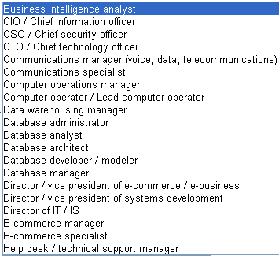
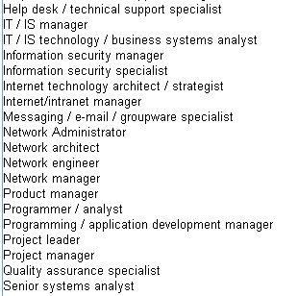

ENTREGA

 Repartirse el total entre todos y preparar un reporte con el formato mostrado en la página # 2 de este documento.

ESTRICTAMENTE, MUY ESTRICTAMENTE: SU TRABAJO DEBE SER INDIVIDUAL

FECHA Mie-31
HORA: 0700
LUGAR: AB-208
ENTREGABLES: Como indicado.
FORMATO: Esta hoja impresa con sus datos llenos, también impresos GRAPADA, GRAPADA a otra hoja similar con código fuente en formato IMPRESO, IMPRESO en hojas blancas, blancas, de 8 ½ X 11, identificadas cada una en la esquina superior derecha con su matrícula y nombre, y con el número de hojas en el formato X de Y; SU TRABAJO DEBE LLEGAR LISTO PARA LA ENTREGA, NO SE ACEPTARÁN TRABAJOS HECHOS MANUALMENTE y A ÚLTIMO MOMENTO EN EL AULA.

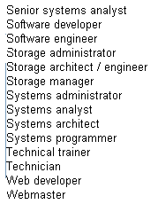

Software developer
http://www.computerworld.com/s/salary-survey/tool/result

Title: Software developer
Years in IT: Less than 10 years
In 2011, a typical person employed as a Software developer with less than 10 years in IT could expect to earn an average compensation of $62,567.
That compensation figure includes salary and bonus.

How do you  compare? | 2011 Total | 2010 Total | Increase or  Decrease
Average of Software developer fitting this profile | $62,567 | $60,123 | 4.1%
National average for Software developer | $84,077 | $82,625 | 1.8%

Job description for Software developer
Responsible for coding, testing, analysis, design, definition, development and implementation of applications systems.

Programmer / analyst
http://www.computerworld.com/s/salary-survey/tool/result

Title: Programmer / analyst
Years in IT: Less than 10 years
In 2011, a typical person employed as a Programmer / analyst with less than 10 years in IT could expect to earn an average compensation of $59,457.
That compensation figure includes salary and bonus.

How do you  compare? | 2011 Total | 2010 Total | Increase or  Decrease
Average of Programmer / analyst fitting this profile | $59,457 | $56,283 | 5.6%
National average for Programmer / analyst | $76,953 | $75,790 | 1.5%

Job description for Programmer / analyst
Analyzes user specifications and requirements. Encodes, tests, debugs and documents programs on large-scale, complex projects. Revises and updates programs and documentation as required.

Programming / application development manager
http://www.computerworld.com/s/salary-survey/tool/result

Title: Programming / application development manager
Years in IT: Less than 10 years
In 2011, a typical person employed as a Programming / application development manager with less than 10 years in IT could expect to earn an average compensation of $86,780. That compensation figure includes salary and bonus.

How do you  compare? | 2011 Total | 2010 Total | Increase or  Decrease
Average of Programming / application development manager fitting this profile | $86,780 | $83,043 | 4.5%
National average for Programming / application development manager | $110,953 | $109,734 | 1.1%

Job description for Programming / application development manager
Oversees systems analysis and programming activities to establish, develop, implement and maintain new or upgraded systems and programs. Supervises the work of programmers.
*This response base is very low. These figures should be used for comparison only.

Project leader
http://www.computerworld.com/s/salary-survey/tool/result

Title: Project leader
Years in IT: Less than 10 years
In 2011, a typical person employed as a Project leader with less than 10 years in IT could expect to earn an average compensation of $65,354.
That compensation figure includes salary and bonus.

How do you  compare? | 2011 Total | 2010 Total | Increase or  Decrease
Average of Project leader fitting this profile | $65,354 | $65,334 | 0%
National average for Project leader | $91,045 | $91,779 | -0.8%

Job description for Project leader
Designs, plans and coordinates work teams. Provides technical support to project team members.
*This response base is very low. These figures should be used for comparison only.

